**HO CHI MINH CITY NATIONAL UNIVERSITY**

**UNIVERSITY OF INFORMATION TECHNOLOGY   
FACULTY OF INFORMATION SYSTEMS**

**DATA ANALYSIS IN BUSINESS**

**FINAL PROJECT: VIETNAMESE STOCK PRICE PREDICTION USING MACHINE LEARNING ALGORITHMS**

**Teacher's Guide:** PhD. Nguyen Dinh Thuan

MsC. Nguyen Thi Viet Huong

**Group name:** Team 4

|  |  |  |
| --- | --- | --- |
| **No.** | **Full Name** | **Student ID** |
| 1 | Le Dinh Quoc Huy | 19521614 |
| 2 | Huynh Dang Nghia | 20521650 |
| 3 | Le Ngoc Mai Thanh | 20521913 |

TP HCM, June 2023

**TEACHER'S COMMENTS**

………………………………………………………………………………………………………………………………………………………………………………………………………………………………………………………………………………………………………………………………………………………………………………………………………………………………………………………………………………………………………………………………………………………………………………………………………………………………………………………………………………………………………………………………………………………………………………………………………………………………………………………………………………………………………………………………………………………………………………………………………………………………………………………………………………………………………………………………………………………………………………………………………………………………………………………………………………………………………………………………………………………………………………………………………………………………………………………………………………………………………………………………………………………………………………………………………………………………………………………………………………………………………………………………………………………………………………………………………………………………………………………………………………………………………………………………………………………………………………………………………………………………………………………………………………………………………………………………………………………………………………………………………………………………………………………………………………………………………………………………………………………………………………………………………………………………………………………………………………………………………………………………………………

# TABLE OF CONTENTS

[I. INTRODUCTION 4](#_Toc138079860)

[1. Vingroup Joint Stock Company (VIC) 4](#_Toc138079861)

[2. CMC Corporation (CMG) 5](#_Toc138079862)

[3. Viet Nam Plastic Corporation (VNP) 5](#_Toc138079863)

[II. RELATED RESEARCH 5](#_Toc138079864)

[III. MATERIALS 5](#_Toc138079865)

[1. Data Description 5](#_Toc138079866)

[2. Performance measure: 5](#_Toc138079867)

[IV. METHODOLOGY 5](#_Toc138079868)

[A. Linear Regression 5](#_Toc138079869)

[B. ARIMA 5](#_Toc138079870)

[C. LSTM 5](#_Toc138079871)

[D. GRU 6](#_Toc138079872)

[E. ARIMAX 8](#_Toc138079873)

[F. KNN 8](#_Toc138079874)

[G. HMM 8](#_Toc138079875)

[H. BSTS 8](#_Toc138079876)

[I. CNN 8](#_Toc138079877)

[V. CONCLUSION 9](#_Toc138079878)

[VI. GROUP WORK DISTRIBUTION 10](#_Toc138079879)

[VII. REFERENCES 11](#_Toc138079880)

# I. INTRODUCTION

Predicting stock prices is a challenging and complex task that has attracted significant attention from researchers and investors alike. For investors, accurate stock price forecasting can offer insightful information that helps them decide whether to purchase, sell, or keep companies. In order to analyze and make predictions about financial data, particularly stock prices, machine learning techniques have become increasingly effective. In this study, we especially focus on applying machine learning algorithms to forecast stock values in the context of Vietnam's stock market.

Vietnam's stock market has experienced significant growth and dynamism in recent years, attracting both domestic and international investors. However, predicting stock prices in this market remains a challenging endeavor due to the inherent complexities and uncertainties associated with financial markets. We will focus on three company: Vingroup Joint Stock Company, CMC Corp, and VNP.

In this study, we aim to apply a range of machine learning algorithms to predict stock prices in Vietnam's stock market. Specifically, we will explore the effectiveness of popular algorithms such as Long Short-Term Memory (LSTM), Gated Recurrent Unit (GRU), K-Nearest Neighbors (KNN), and Autoregressive Integrated Moving Average (ARIMA),... These algorithms possess unique strengths and capabilities, making them suitable for modeling and predicting stock price trends. After that, we can evaluate each algorithm by using appropriate performance metrics, such as mean absolute percentage error (MAPE) and root mean squared error (RMSE).

Overall, this paper aims to contribute to the field of stock price prediction in Vietnam by leveraging the power of machine learning algorithms. By harnessing the potential of these techniques, we seek to enhance the accuracy and reliability of stock price predictions, enabling stakeholders in Vietnam's stock market to make well-informed investment decisions.

## Vingroup Joint Stock Company (VIC)

Vingroup Joint Stock Company, commonly known as Vingroup, is a prominent conglomerate and one of the leading private enterprises in Vietnam. Established in 1993, Vingroup has rapidly expanded its operations across diverse industries, including real estate development, retail, hospitality, healthcare, education, and automotive manufacturing.

With its headquarters in Hanoi, Vietnam, Vingroup has become a household name in the country, known for its innovative and ambitious ventures. The company has played a crucial role in transforming Vietnam's economic landscape through its investments in various sectors, contributing to the country's overall development and growth.

*Figure 1: VIC’s stock price from 2017 to 2023*

## CMC Corporation (CMG)

CMC Corporation, commonly known as CMC Corp, is a prominent technology corporation based in Vietnam. With a history dating back to 1993, CMC Corp has established itself as a leading player in the country's information technology and communications sector.

Headquartered in Hanoi, Vietnam, CMC Corp offers a wide range of technology solutions and services to clients across various industries. The company has built a strong reputation for its expertise in digital transformation, software development, cloud computing, cybersecurity, and telecommunications.

CMC Corp has played a vital role in shaping Vietnam's digital landscape by providing innovative and cutting-edge technology solutions. The company's portfolio includes software development for enterprise applications, e-commerce platforms, and mobile applications, catering to the evolving needs of businesses in the digital era.

*Figure 2: CMG’s stock price from 2017 to 2023*

## Viet Nam Plastic Corporation (VNP)

Vietnam Plastic Corporation is a Vietnam-based company, which is mainly engaged in the merchant wholesale of commodity chemicals. The Company's leading products include biaxially oriented polypropylene (BOPP) films; polypropylene (PP), polyethylene (PE) and polyvinyl chloride (PVC) resins, as well as PVC additives. Besides, the Company partakes in the leasing of industrial machinery and equipment, the distributing of industrial supplies, the manufacturing of plastic packaging, together with the letting of commercial properties. The Company also conducts various studies on the production and application of plastic materials.

*Figure 3: VNP’s stock price from 2017 to 2023*

# II. RELATED RESEARCH

Several studies have been conducted to explore various algorithms, data preprocessing techniques, feature selection methods, and evaluation metrics in the context of stock price prediction. This section presents a review of the related work conducted in this paper:

P.-F. Pai and C.-S. Lin develop a hybrid model combining autoregressive integrated moving average (ARIMA) and support vector machines (SVM) for stock price forecasting.[1]. Aside from that, S. Hochreiter and J. Schmidhuber [2] investigated the effectiveness of long short-term memory (LSTM) neural networks for stock price prediction. They proposed an LSTM-based model that incorporated both historical stock price data and technical indicators as input features. The study demonstrated that LSTM is a powerful architecture for sequential data analysis, addressing the limitations of traditional RNNs. In addition, to forecast stock index, Michael van Gysen et al. [3]employ both linear and non-linear models. Moreover, we use the result of “Predicting prices of stock market using gated recurrent units (GRUs) neural networks”[4] and apply GRU into our research.

# III. MATERIALS

## Data Description

We collected three datasets on Investing.com from December 1st, 2017 to June 9, 2023. The data related to stock price of three large company in Vietnam: Vingroup JSC(VIC), CMC Corp(CMG) and Viet Nam Plastic Corp(VNP) .The dataset has 7 attribute columns including:

* Date: stock trading opening day.
* Price (or Close Price): the last price at which a stock trades upon the end of the exchange.
* Open: the first price which a stock opens for trading.
* High: the highest stock price of the day.
* Low: the lowest stock price of the day.
* Vol: the number of shares that the trader buys and sells.
* Change%: today's change in stock price from the previous day expressed as a percentage.

## Performance measure:

Starting with pre-processing data, we cleaned the dataset by dropping the missing values, changing the data type of attributes, feature selection,…After that, we divided the data into training, testing and validate sets with two ratios: 70%-20%-10% and 60%-20%-20%.In this study, we employ the root means square error (RMSE) ,the MAPE and MAE as three performance measures to evaluate the prediction capability of our models.

# IV. METHODOLOGY

1. **Linear Regression**

Linear regression is used to predict the value of a variable based on the value of another variable. The variable need to predict is called the dependent variable. The variable that is used to predict the other variable's value is called the independent variable. Linear regression fits a straight line or surface that minimizes the discrepancies between predicted and actual output values.  [5]

A multiple linear regression model has the formula as below: [6]

$$Y= β_{0}+ β_{1}X_{1}+ β_{2}X_{2}+…+β_{n}X_{n}+ ε$$

Where:

* **Y** is the dependent or predicted variable.
* **X\_1,…X\_n** are the independent (explanatory) variables.
* **β\_0** is the intercept term.
* **β\_1,… β\_n** are the regression coefficients for the independen variables.
* **ε** is the random error.

1. **ARIMA**

The acronym ARIMA represents Autoregressive Integrated Moving Average [9]. The ARIMA model incorporates three key elements from the Box and Jenkins approach: autoregressive (AR) modeling, moving average (MA) modeling, and integration. These components are combined into an ARIMA (p, d, q) model. ARIMA is a time-based quantitative forecasting model that predicts future values of a predictor variable based on the historical trend of that variable.

Where:

* p defines the AR
* d defines the differential
* q defines the MA.

The ARIMA model consists of three components/parameters: AR, I, and MA. The AR component is represented by "p" in the ARIMA (p, d, q) notation, indicating the weighted linear sum of "p" lagged values. The value of "p" indicates the number of lagged orders considered in the model. The formula to denote this AR is shown (1)

$$Y_{t}=β1*Yt-1+..+βp*Yt-p+ε=ε+\sum_{j=1}^{p}{ }\left(β_{j}*Y_{t-j}\right)$$

(1)

Where p is used to calculate the number of orders of previous values, t is a time series, the AR model's coefficient, and an error term with a mean of zero and a variance of two. The ARIMA (p, d, q) classification, which displays an erroneous value in (4), denotes the MA process by order q. It also employs the number of orders in the past values, as denoted in (2).

$Yt=α_{1}*ε_{t-1}+…+α_{q}*ε_{t-q}+ε_{t}=ε_{t}+\sum_{j=1}^{p}{ }\left(α_{j}*ε_{t-j}\right)$

(2)

Where t is the time series, denotes the slope coefficient by order α, and q denotes the quantity of orders required to locate the historical values. The q option is used to specify how many orders are included in the AR computation. The number of times the time series was differentiated determines how integrated or differentiated versions are indicated in the formula ARIMA (p, d, q).(3)(4)

$$\begin{aligned}I\left(1\right)=∇y_{t}=y_{t}-y_{t-1} \\ I\left(d\right)=∇^{d}\left(y_{t}\right)=∇\left(∇\left(…..∇\left(\left(y_{t}\right)\right)\right)\right.\end{aligned}$$

(3)(4)

Two formulas (5) and (6) are shown below to illustrate the difference between ARMA(p,q), alternatively one may write ARMA(p,0,q) because the difference is zero, and ARIMA(p,d, q).

$$Y_{t}=ε_{t}+\sum_{j=1}^{p}{ }\left(α_{j}*ε_{t-j}\right)+\sum_{j=1}^{p}{ }\left(β_{j}*Y_{t-j}\right)$$

Equation for an ARMA (p , q) model(5)

$$\tilde{N}Y_{t}=ε_{t}+\sum_{j=1}^{p}{ }\left(α_{j}*ε_{t-j}\right)+\sum_{j=1}^{p}{ }\left(β_{j}*∇Y_{t-j}\right)$$

Equation for an ARIMA (p , d , q) model(6)

1. **LSTM**

Long Short-Term Memory (LSTM) is a type of recurrent neural network (RNN) that is well-suited for processing sequential data such as time series, natural language, and audio. LSTMs are able to learn long-term dependencies in data by using a special structure called a ‘memory cell’ which can store information over long periods of time. LSTM models are often used for time series prediction tasks, such as forecasting stock prices, weather, or energy consumption. In these tasks, the goal is to use past data to make predictions about future value. [7]

The structure of an LSTM cell is shown in the figure below. It consists of three interacting gates (input, output, and forget gates) and a memory cell, which stores information. The gates control the flow of information into and out of the memory cell, allowing the model to decide which information to keep and which to discard

[8]

***Figure 4. LSTM Architecture Flow Diagram***

Forget gate: f1 = σ (Wf Xt + Ufht-1)

Input gate: it = σ (WiXt + Ui ht -1 )

Output gate: ot = ϕ h(W0Xt + U0ht – 1)[9]

1. **GRU**

A gated recurrent unit (GRU) is a gating mechanism in [recurrent neural networks](https://deepai.org/machine-learning-glossary-and-terms/recurrent-neural-network) (RNN) similar to a [long short-term memory](https://deepai.org/machine-learning-glossary-and-terms/long-short-term-memory) (LSTM) unit but without an output gate. GRU’s try to solve the [vanishing gradient problem](https://deepai.org/machine-learning-glossary-and-terms/vanishing-gradient-problem) that can come with standard recurrent [neural networks](https://deepai.org/machine-learning-glossary-and-terms/neural-network). [10]

GRU uses gating mechanisms to selectively update the hidden state of the network at each time step. The gating mechanisms are used to control the flow of information in and out of the network. The GRU has two gating mechanisms, called the reset gate and the update gate.[11]

The update gate controls information that flows into memory, and the reset gate controls the information that flows out of memory. The update gate and reset gate are two vectors that decide which information will get passed on to the output. They can be trained to keep information from the past or remove information that is irrelevant to the prediction.

[12]

*Figure 5. GRU Architecture Flow Diagram*

**Notation:**

h_t : hidden layer vectors.  
x_t : input vector.  
b_z , b_r , b_h : bias vector.  
W_z , W_r , W_h : parameter matrices.  
\sigma , \tanh : activation functions.

The equations used to calculate the reset gate, update gate, and hidden state of a GRU are as follows[5]:

* **Reset gate: $r_{t}$** = sigmoid($W_{r}$\* [$h_{t-1}$, $x_{t}$])
* **Update gate**: $z_{t}$ = sigmoid( $W_{z}$\* [$h_{t-1}$, $x_{t}$])
* **Candidate hidden state: ${h_t}^{\sim }$** = tanh($W_{h}$\* [$r_{t}$ $h_{t-1}$\* , $x_{t}$])
* **Hidden state: $h_{t}$** = (1 – $z_{t}$) $h_{t-1}$\* + $z_{t}$ ${h_t}^{\sim }$

\*

Where:

$h_{t-1}$ is the previous hidden state, and $h_{t}$ is the current hidden state.

1. ARIMAX

ARIMAX, an acronym for Auto Regressive Integrated Moving Average with eXogenous inputs, is a popular and efficient model for time series prediction. It extends the well-known ARIMA model by incorporating exogenous variables to improve forecasting accuracy [13].

ARIMA, or Auto-Regressive Integrated Moving Average, models a given time series based on its own prior values, lags, and lagged forecast errors. It is defined by three terms: p, d, q, where p is the order of the Auto-Regressive (AR) term, d is the number of differences needed to make the time series stationary, and q is the order of the Moving Average (MA) term. The AR term relates to the number of lags of the time series to be used as predictors, while the MA term refers to the number of lagged forecast errors that should conform to the ARIMA Model. The series is differentiated (d times) to ensure stationarity, and then the AR and MA terms are combined to form the ARIMA model​ [13].

However, ARIMA models only consider the time series itself for forecasting, which may not be sufficient when external factors play a significant role in the time series behavior. This limitation is addressed by the ARIMAX model, which incorporates an additional term 'X' that denotes exogenous variables. These variables can be any factors external to the time series that are believed to have an impact on it. In other words, these are additional predictors that can improve the forecast accuracy when used alongside the historical time series data​ [14]​.

The ARIMAX equation is represented as:

$$ΔP_{t}=c+βX+ϕ_{1}ΔP_{t-1}+θ_{1}ϵ_{t-1}+ϵ_{t}$$

Where:

$P_{t}$ and $P_{t1}$ represent the values in the current period and one period ago respectively.

$ϵ_{t}$ and $ϵ_{t-1}$ are the error terms for the same two periods.

c is a baseline constant factor.

$ϕ_{1}$ and $θ_{1}$ are parameters that express what parts of the value $P_{t1}$ and error $ϵ_{t-1}$ last period are relevant in estimating the current one.

X is the exogenous variable, and β is its coefficient which will be estimated based on the model selection and the data.

The exogenous variable X could be any variable of interest such as a time-varying measurement like the inflation rate or the price of a different index, a categorical variable separating the different days of the week, a Boolean accounting for the special festive periods, or a combination of several different external factors. The only requirement is that this variable should have a potential impact on the time series and its data should be available​ [​18]​.

In conclusion, ARIMAX is a powerful tool for forecasting time series data, especially when the influence of external factors is significant. It leverages the strengths of the ARIMA model and extends it by incorporating relevant exogenous variables, providing a more comprehensive and accurate forecasting model.

1. KNN

The K-Nearest Neighbors is a classification algorithm in Machine Learning, which uses similarity or proximity to make classifications or predictions about the grouping of an individual data point. It can be used for either regression or classification problems. [15]

In the KNN algorithm, the "k" represents the number of nearest neighbors used to make predictions. Given a new, unseen data point, KNN identifies the "k" closest neighbors to that point in the training dataset based on a distance metric, commonly Euclidean distance. The prediction is then determined by a majority vote (for classification) or the average of the target values (for regression) of those "k" neighbors.

* Euclidean distance:

d = $\sqrt{{(x_{2}-x_{1})}^{2}+ {(y_{2}-y_{1})}^{2}}$

Where:

* ($x_{1}$, $y_{1}$) are the coordinates of one point.
* ($x_{2}$, $y_{2}$) are the coordinates of the other point.

1. HMM

The Hidden Markov model (HMM) is a statistical probabilistic model in the field of machine learning and natural language processing. It is used to discover hidden patterns within that data. The Hidden Markov model (HMM) is a statistical model that contains hidden and unknown parameters. In this model, the observed parameters are used to identify the hidden parameters.[16]

An HMM is defined by four components: a set of hidden states, a set of observations, a state transition probability matrix, and an observation probability matrix. The Forward-Backward algorithm and the Viterbi algorithm are two commonly used methods to estimate the parameters of an HMM and solve related problems. HMM is usually used for speech recognition, character recognition, machine translation and many more applications. [16]

1. BSTS

Bayesian Structural Time Series (BSTS) is a statistical method utilized in feature selection, time series forecasting, nowcasting, and inferring causal impact, among other applications. It is particularly useful in analyzing time series data, with applications in analytical marketing, like assessing the impact of different marketing campaigns on key indicators such as web search volumes, product sales, and brand popularity​ .[17]

The BSTS model comprises three main components: the Kalman filter, the Spike-and-slab method, and Bayesian model averaging. The Kalman filter, a technique for time series decomposition, allows the addition of different state variables like trend, seasonality, and regression. The Spike-and-slab method is responsible for selecting the most important regression predictors. Finally, Bayesian model averaging combines the results and calculates the prediction. The model is adept at inferring causations through counterfactual prediction and observed data​. [17]

BSTS models are a class of additive models for time series data and have an associated state space, which provides a probabilistic model for the serial correlation observed in the time series. The simplest version of STS is the local level model, where y(t) is the sum of our state variable α(t) plus Gaussian Noise, ϵ(t). All of the time dependency is modeled in the evolution of α(t+1), which is equal to its previous time value α(t) plus Gaussian Noise, η(t) that is independent of all ϵ(i's)​. [18]

The local level state space representation is as follows:

Measurement Equation: $y_{t}=α_{t}+ϵ_{t}$

State Equation: $α_{t+1}=α_{t}+η_{t}$

This can also be compactly represented as:

$$α_{t+1}|α_{t}∼\text{Normal}(α_{t},σ_{η}^{2})$$

$$y_{t}|α_{t}∼\text{Normal}(α_{t},σ_{ϵ}^{2})$$

In the Bayesian context, priors are assigned to σϵ, ση, and the initial state α1:

$$σ_{ϵ}∼\text{Gamma}({\text{shape}}_{ϵ},{\text{rate}}_{ϵ})$$

$$σ_{η}∼\text{Gamma}({\text{shape}}_{η},{\text{rate}}_{η})$$

$$α_{1}∼\text{Normal}(a_{1},p_{1}^{2})$$

Despite its powerful applications, the BSTS model has a complex mathematical foundation and may be challenging to implement as a computer program. However, the programming language R provides ready-to-use packages for calculating the BSTS model, which does not require a strong mathematical background from a researcher​. [17]

1. CNN

CNN (Convolutional Neural Network) is a neural network architecture used in the field of computer vision and image processing. [19]

The architecture of CNN includes main layers such as convolutional layer, pooling layer and fully connected layer. The convolutional layer is a crucial component in CNN and is used to extract from the input data. The pooling method is often applied after the convolutional layer and retains the most important information in the data. The fully connected layer is typically used at the end of a CNN to connect the extracted data from the convolutional and pooling layers to the desired output. To apply CNN to stock price prediction based on time series data, we can use Convolutional LSTM (Long Short-Term Memory), which combines convolutional layers and LSTM to predict future stock prices. [19]

1. RESULT

In this evaluation, five distinct models were assessed, to be specific LSTM, ARIMA, ARIMAX, BSTS, CNN, GRU, HMM, KNN, BSTS for the time series examination on 7-2-1, 6-3-1 training, testing and validating.

RMSE and MAPE scores were used to assess model execution. In the table show the forecasting metrics results for examining test data of the dataset. From the outcomes, one can without much of a stretch see that LSTM has better execution compared to different models for all evaluation metrics.

LSTM has performed well in all train-test set. The RMSE values of LSTM are the lowest in all model. The best MAPE score is 2,4496% which is for LSTM by the data at the rate 7-2-1 train-test-validate in CMG stock. Best RMSE is 612.8284 for 6-3-1 train-test-validate split in VNP stock by LSTM.

In general, the LSTM model is the best of all the 9 models with the RMSE smaller than almost and smallest MAPE. The remaining models like HMM, ARIMA, ARIMAX, Linear, BSTS, KNN, CNN have higher results but they will be useful in certain cases. From the conclusions on the model, LSTM is a suitable model for predicting future prices in the next 30 days of 2 stocks VNP, VIC and CMG.

|  |  |  |  |  |  |  |  |  |
| --- | --- | --- | --- | --- | --- | --- | --- | --- |
| Stock | Model | Train-Test-Validate | RMSE | | MAE | | MAPE | |
| Test | Validate | Test | Validate | Test | Validate |
| VNP | Linear Regression | 7 - 2 - 1 | 6705,4113 | 8576,6570 | 5425,2525 | 8520,3678 | 29,6445% | 76,5021% |
| 6 - 3 - 1 | 11786,6837 | 1625,8334 | 10320,9258 | 1128,8681 | 48,9156% | 8,9304% |
| 5-3-2 | 14498,9391 | 8244,6292 | 12740,0715 | 7869,4357 | 65,8464% | 59,6390% |
| ARIMA | 7 - 2 - 1 | 6876,2283 | 13708,8328 | 5779,9906 | 13583,0137 | 40,28% | 122,38% |
| 6 - 3 - 1 | 51021,0351 | 19921,6651 | 41517,2406 | 18272,7401 | 265,28% | 156,46% |
| 5-3-2 | 11955,5393 | 5386,9104 | 9781,7667 | 4785,714 | 46,4039% | 34,8333% |
| ARIMAX | 7 - 2 - 1 | 6876,2279 | 9847,5470 | 5779,9903 | 9671,8292 | 40,2829% | 87,6482% |
| 6 - 3 - 1 | 51021,0352 | 111941,2746 | 41517,2407 | 111659,6617 | 265,2841% | 985,6987% |
| 5-3-2 | 11056,5205 | 3870,2611 | 8945,1835 | 3026,1855 | 42,0272% | 20,8359% |
| KNN | 7 - 2 - 1 | 8850,7323 | 14426,7554 | 7335,8163 | 14362,0968 | 51,4605% | 128,8006% |
| 6 - 3 - 1 | 7727,1842 | 2836,7405 | 6071,4674 | 2596,7742 | 27,7561% | 24,1369% |
| 5-3-2 | 11931,8284 | 5359,2433 | 9748,8225 | 4754,7908 | 46,1487% | 34,5549% |
| GRU | 7 - 2 - 1 | 573,8826 | 499,8579 | 417,4841 | 380,6627 | 3,0448% | 2,8628% |
| 6 - 3 - 1 | 831,1484 | 507,8175 | 616,0793 | 392,4666 | 3,3434% | 2,9652% |
| 5-3-2 | 895,3547 | 595,5328 | 633,2848 | 420,9076 | 3,1074% | 3,7589% |
| LSTM | 7 - 2 - 1 | 2131,1439 | 629,3612 | 1889,2698 | 499,9287 | 13.3590% | 3.7612% |
| 6 - 3 - 1 | 1945,5576 | 612.8284 | 1627,7082 | 453,7555 | 8.2710% | 3.3955% |
| 5-3-2 | 22206,3181 | 1967,7859 | 18787,0533 | 1720,1195 | 80,804% | 15,3808% |
| HMM | 7 - 2 - 1 | 34760.701 | 46155.37 | 32913,5501 | 46069,9186 | 202.81  % | 410.47  % |
| 6 - 3 - 1 | 77020.87 | 146437.52 | 58149,8203 | 143015,1079 | 79.61  % | 262.28  % |
| 5-3-2 | 29135.70 | 37405.59 | 22147.42 | 34058.94 | 197.16 | 295.29 |
| CNN | 7 - 2 - 1 | 669.88 | 7061.0 | 6713.19 | 472.31 | 3.507% | 45.91% |
| 6 - 3 - 1 | 986.977 | 6033.97 | 5613.39 | 866.95 | 6.74% | 31.92% |
| 5-3-2 | 1900,75 | 908,75 | 1469.0 | 653.12 | 7.10% | 6.05% |
| BSTS | 7 - 2 - 1 | 19930,3560 | 38518,7278 | 16922,9333 | 39602,396 | 115,59% | 342,35% |
| 6 - 3 - 1 | 7845,0716 | 15910,7817 | 6850,8131 | 15584,8095 | 39,26% | 141,54% |
| 5-3-2 | 5840,2524 | 12934,2062 | 4254,5909 | 12194,4333 | 19,1399% | 103,6286% |

|  |  |  |  |  |  |  |  |  |
| --- | --- | --- | --- | --- | --- | --- | --- | --- |
| Stock | Model | Train - Test - Validate | RMSE | | MAE | | MAPE | |
| Test | Validate | Test | Validate | Test | Validate |
| VIC | Linear Regression | 7 - 2 - 1 | 24021,5540 | 42638,5307 | 20138,5591 | 42383,3706 | 29,7747% | 77,5511% |
| 6 - 3 - 1 | 18183,8998 | 36990,5445 | 14649,2624 | 36715,5014 | 19,7285% | 67,1999% |
| 5-3-2 | 10569,4163 | 37774,8983 | 8269,1735 | 36732,9699 | 9,0157% | 63.1026% |
| ARIMA | 7 - 2 - 1 | 20405,1731 | 37756,4391 | 17076 | 37471,0144 | 25,19% | 68,63% |
| 6 - 3 - 1 | 20869,9985 | 42919,3837 | 16640,2961 | 42668,2517 | 22,94% | 78,01% |
| 5-3-2 | 16746,8134 | 21960,7418 | 13764,4441 | 20140,2463 | 13,6764% | 35,4557% |
| ARIMAX | 7 - 2 - 1 | 25357,3146 | 50388,5401 | 20865,2541 | 50144,1307 | 31,0172% | 91,6784% |
| 6 - 3 - 1 | 30506,7150 | 62529.9466 | 24537,2732 | 62351,228 | 34,0761% | 113,7349% |
| 5-3-2 | 13513,9784 | 34183,5928 | 10990,921 | 33007,1003 | 11,1824% | 56,9152% |
| KNN | 7 - 2 - 1 | 17248,0208 | 32794,7675 | 14849,7225 | 32465,7513 | 21,4424% | 59,5454% |
| 6 - 3 - 1 | 19148,9080 | 39481,0009 | 15284,1748 | 39207,8518 | 20,7548% | 71,7398% |
| 5-3-2 | 15479,6349 | 23464,6177 | 12576,0607 | 21770,2464 | 12,4885% | 38,1704% |
| GRU | 7 - 2 - 1 | 1532,9772 | 1432,9859 | 1197,8723 | 1339,8573 | 1,8067% | 2,5723% |
| 6 - 3 - 1 | 1764,9002 | 1825,2732 | 1268,0360 | 1757,3485 | 1,6673% | 3,3729% |
| 5-3-2 | 2070,0841 | 2065,7434 | 1422,3379 | 1737,3327 | 1,4639% | 3,0972% |
| LSTM | 7 - 2 - 1 | 2266,7299 | 3859,0341 | 1690.9932 | 3760.9543 | 2,6823% | 7,2275% |
| 6 - 3 - 1 | 2714,1847 | 4551,5521 | 2028.0744 | 4459.2084 | 2,8147% | 8,5608% |
| 5-3-2 | 3451.5149 | 4918.3503 | 2523.8062 | 4522.0482 | 2.6116% | 8.2376% |
| HMM | 7 - 2 - 1 | 70034.18 | 106675.45 | 51489.7864 | 78084.17 | 67.89  % | 141.76  % |
| 6 - 3 - 1 | 82080.45 | 72683.26 | 75333.6213 | 5282856546.7625 | 93.07  % | 132.19  % |
| 5-3-2 | 75683.26 | 80932.56 | 67899.8616 | 78039.1304 | 74.9788% | 127.723% |
| CNN | 7 - 2 - 1 | 1688,2491 | 2129,5281 | 1218.2649 | 1991.5653 | 1,9089% | 3,8376% |
| 6 - 3 - 1 | 2169,7258 | 1953,1569 | 1521.784 | 1712.9972 | 2,0229% | 3,3080% |
| 5-3-2 | 2849.1161 | 4738.5447 | 2003.9851 | 4483.5166 | 2.0339% | 8.1953% |
| BSTS | 7 - 2 - 1 | 13993,5141 | 13822,0625 | 12651,1306 | 10819,0912 | 15,91% | 20,1284% |
| 6 - 3 - 1 | 33229,3412 | 72332,9580 | 26505,6132 | 72564,3898 | 36,64% | 131,36% |
| 5-3-2 | 37085,0445 | 3417,4684 | 33821,524 | 33492,7914 | 35,3537% | 55,3538% |

|  |  |  |  |  |  |  |  |  |
| --- | --- | --- | --- | --- | --- | --- | --- | --- |
| Stock | Model | Train - Test - Validate | RMSE | | MAE | | MAPE | |
| Test | Validate | Test | Validate | Test | Validate |
| CMG | Linear Regression | 7 - 2 - 1 | 14916,1848 | 1488,4017 | 13911,5560 | 1108,3702 | 26,9914% | 2,7252% |
| 6 - 3 - 1 | 15015,5321 | 4229,8548 | 12698,9460 | 3973,0642 | 25,3999% | 9,6322% |
| 5-3-2 | 11340,2167 | 11432,1163 | 7995,7682 | 8808,9177 | 17,2138% | 17,7806% |
| ARIMA | 7 - 2 - 1 | 5695,18 | 8761,4162 | 4210,1862 | 8593,0208 | 8,96% | 21,31% |
| 6 - 3 - 1 | 18200,6084 | 11495,4326 | 15589,3231 | 11357,4713 | 31,26% | 27,76% |
| 5-3-2 | 14725,7484 | 18657,5985 | 10346,3932 | 17478,4376 | 22,0021% | 37,5778% |
| ARIMAX | 7 - 2 - 1 | 7600,8420 | 20642,5428 | 5100,3450 | 20587,0403 | 11,6675% | 50,7887% |
| 6 - 3 - 1 | 15745,3340 | 6439,3774 | 13349,2214 | 6194,8839 | 26,6947% | 15,0570% |
| 5-3-2 | 12299,9145 | 14034,0194 | 8553,705 | 12406,416 | 18,1832% | 26,0736% |
| KNN | 7 - 2 - 1 | 5679,2231 | 8947,9238 | 4173,4864 | 8783,1051 | 8,9284% | 21,7837% |
| 6 - 3 - 1 | 17185,6526 | 10299,2408 | 14775,8110 | 10145,0175 | 29,7817% | 24,7815% |
| 5-3-2 | 14530,0045 | 18386,5839 | 10176,9799 | 17188,8530 | 21,6183% | 36,9216% |
| GRU | 7 - 2 - 1 | 1709,6574 | 711,5558 | 1279,1798 | 503,0782 | 2,6017% | 1,1873% |
| 6 - 3 - 1 | 1544,7219 | 778,7477 | 1186,3065 | 479,0683 | 2,4023% | 1,1232% |
| 5-3-2 | 1217,3477 | 1020,2692 | 859,7465 | 706,2278 | 2,0536% | 1,7693% |
| LSTM | 7 - 2 - 1 | 1991,8957 | 1088,8324 | 1555.4053 | 1024.6935 | 3,2028% | 2,4496% |
| 6 - 3 - 1 | 2754,2221 | 1300,1124 | 2359.4824 | 1090.5974 | 4,6496% | 2,5880% |
| 5-3-2 | 1348.894 | 1185.2586 | 972.1159 | 806.2833 | 2.3412% | 2.0193% |
| HMM | 7 - 2 - 1 | 15847.72 | 22637.91 | 14421.007 | 22074.9064 | 36.39  % | 54.69  % |
| 6 - 3 - 1 | 50440.31 | 52939.41 | 42715.53 | 46595.4244 | 106.73  % | 114.96  % |
| 5-3-2 | 1957442996.4125 | 2277981685.6252 | 1881544441.9805 | 2254407186.6521 | 99.9945% | 99.9971% |
| CNN | 7 - 2 - 1 | 2305,0413 | 1363,0967 | 1813.5836 | 1039.0802 | 3,5760% | 2,4526% |
| 6 - 3 - 1 | 3433,9172 | 1694,5405 | 2848.6615 | 1480.5456 | 5,8425% | 3,5075% |
| 5-3-2 | 2719.6329 | 2566.0268 | 1949.5389 | 2056.999 | 4.3505% | 5.151% |
| BSTS | 7 - 2 - 1 | 9299,7939 | 19297,1344 | 7701,0606 | 18654,1835 | 16,11% | 47,4% |
| 6 - 3 - 1 | 7619,6664 | 18188,7130 | 6277,1320 | 17512,9156 | 14,67% | 44,45% |
| 5-3-2 | 12476,1907 | 12287,3062 | 9022,772 | 9652,5054 | 19,7341% | 19,5909% |

Predictive results of the HMM model for CMG with the rate of 7-2-1 (%)

Predictive results of the HMM model for CMG with the rate of 6-3-1 (%)

Predictive results of the HMM model for CMG with the rate of 5-3-2 (%)

Predictive results of the CNN model for VIC with the rate of 7-2-1 (%)

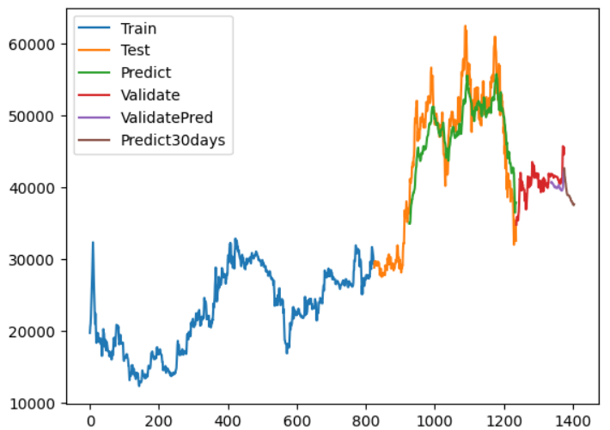

Predictive results of the CNN model for VIC with the rate of 6-3-1 (%)

Predictive results of the CNN model for VIC with the rate of 5-3-2 (%)

Predictive results of the LSTM model for CMG with the rate of 7-2-1 (%)

Predictive results of the LSTM model for CMG with the rate of 6-3-1 (%)

Predictive results of the LSTM model for CMG with the rate of 5-3-2 (%)

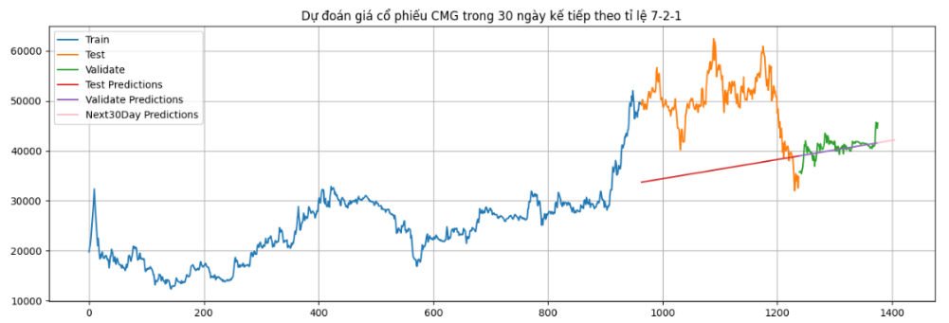

Predictive results of the Linear Regression model for CMG with the rate of 7-2-1(%)

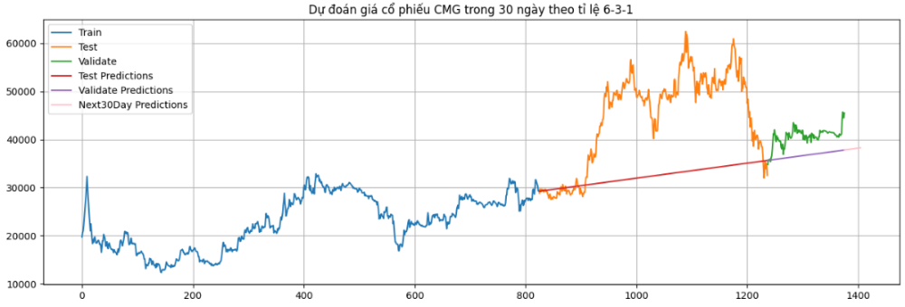

Predictive results of the Linear Regression model for CMG with the rate of 6-3-1 (%)

Predictive results of the Linear Regression model for CMG with the rate of 5-3-2 (%)

Predictive results of the BSTS model for CMG with the rate of 7-2-1 (%)

Predictive results of the BSTS model for CMG with the rate of 6-3-1 (%)

Predictive results of the BSTS model for CMG with the rate of 5-3-2 (%)

Predictive results of the ARIMA model for CMG with the rate of 7-2-1 (%)

Predictive results of the ARIMA model for CMG with the rate of 6-3-1 (%)

Predictive results of the ARIMA model for CMG with the rate of 5-3-2 (%)

Predictive results of the ARIMAX model for CMG with the rate of 7-2-1 (%)

Predictive results of the ARIMAX model for CMG with the rate of 6-3-1 (%)

Predictive results of the ARIMAX model for CMG with the rate of 5-3-2 (%)

Predictive results of the GRU model for CMG with the rate of 7-2-1 (%)

Predictive results of the GRU model for CMG with the rate of 6-3-1 (%)

Predictive results of the GRU model for CMG with the rate of 5-3-2 (%)

Predictive results of the KNN model for CMG with the rate of 7-2-1 (%)

Predictive results of the KNN model for CMG with the rate of 6-3-1 (%)

Predictive results of the KNN model for CMG with the rate of 5-3-2 (%)

Predictive results of the HMM model for VIC with the rate of 7-2-1 (%)

Predictive results of the HMM model for VIC with the rate of 6-3-1 (%)

Predictive results of the HMM model for VIC with the rate of 5-3-2 (%)

Predictive results of the CNN model for VIC with the rate of 7-2-1 (%)

Predictive results of the CNN model for VIC with the rate of 6-3-1 (%)

Predictive results of the CNN model for VIC with the rate of 5-3-2 (%)

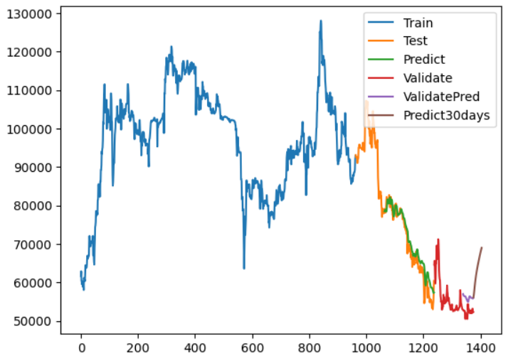

Predictive results of the LSTM model for VIC with the rate of 7-2-1 (%)

Predictive results of the LSTM model for VIC with the rate of 6-3-1 (%)

Predictive results of the LSTM model for VIC with the rate of 5-3-2 (%)

Predictive results of the Linear Regression model for VIC with the rate of 7-2-1 (%)

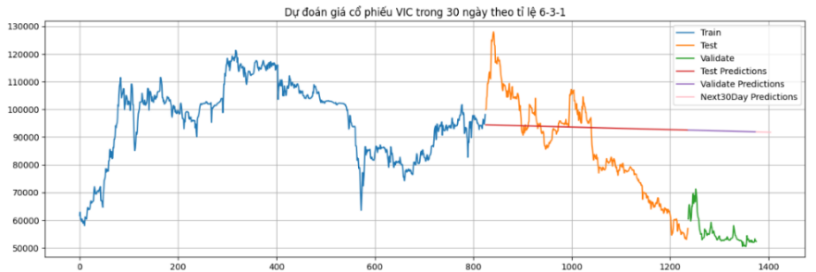

Predictive results of the Linear Regression model for VIC with the rate of 6-3-1 (%)

Predictive results of the Linear Regression model for VIC with the rate of 5-3-2 (%)

Predictive results of the BSTS model for VIC with the rate of 7-2-1 (%)

Predictive results of the BSTS model for VIC with the rate of 6-3-1 (%)

Predictive results of the BSTS model for VIC with the rate of 5-3-2 (%)

Predictive results of the ARIMA model for VIC with the rate of 7-2-1 (%)

Predictive results of the ARIMA model for VIC with the rate of 6-3-1 (%)

Predictive results of the ARIMA model for VIC with the rate of 5-3-2 (%)

Predictive results of the ARIMAX model for VIC with the rate of 7-2-1 (%)

Predictive results of the ARIMAX model for VIC with the rate of 6-3-1 (%)

Predictive results of the ARIMAX model for VIC with the rate of 5-3-2 (%)

Predictive results of the GRU model for VIC with the rate of 7-2-1 (%)

Predictive results of the GRU model for VIC with the rate of 6-3-1 (%)

Predictive results of the GRU model for VIC with the rate of 5-3-2 (%)

Predictive results of the KNN model for VIC with the rate of 7-2-1 (%)

Predictive results of the KNN model for VIC with the rate of 6-3-1 (%)

Predictive results of the KNN model for VIC with the rate of 5-3-2 (%)

Predictive results of the HMM model for VNP with the rate of 7-2-1 (%)

Predictive results of the HMM model for VNP with the rate of 6-3-1 (%)

Predictive results of the HMM model for VNP with the rate of 5-3-2 (%)

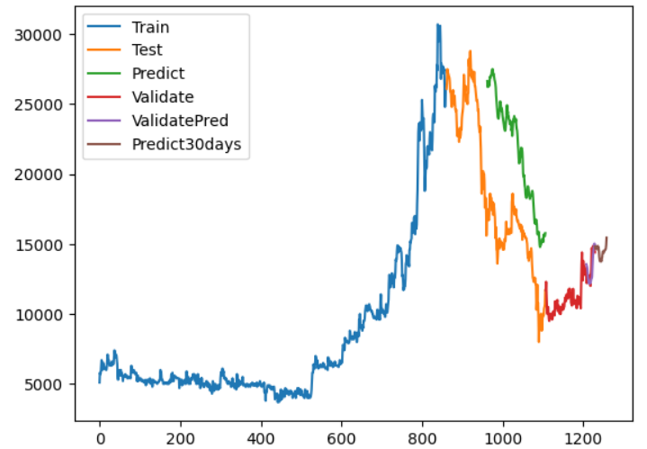

Predictive results of the CNN model for VNP with the rate of 7-2-1 (%)

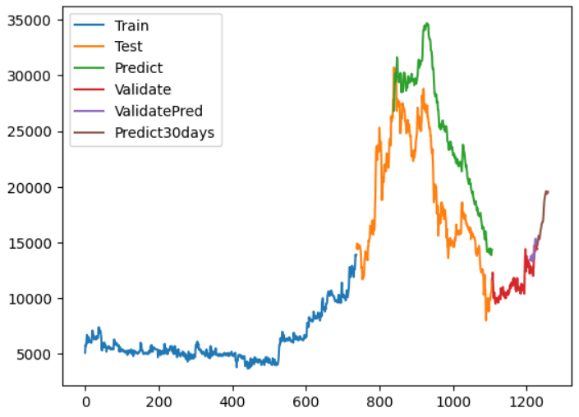

Predictive results of the CNN model for VNP with the rate of 6-3-1 (%)

Predictive results of the CNN model for VNP with the rate of 5-3-2 (%)

Predictive results of the LSTM model for VNP with the rate of 7-2-1 (%)

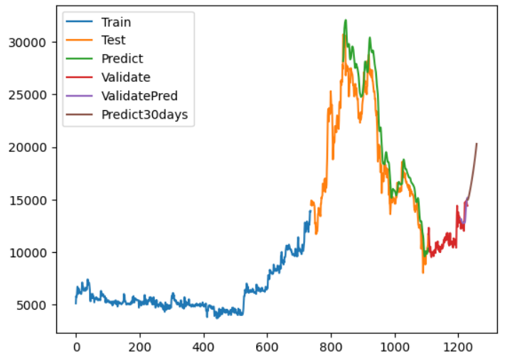

Predictive results of the LSTM model for VNP with the rate of 6-3-1 (%)

Predictive results of the LSTM model for VNP with the rate of 5-3-2 (%)

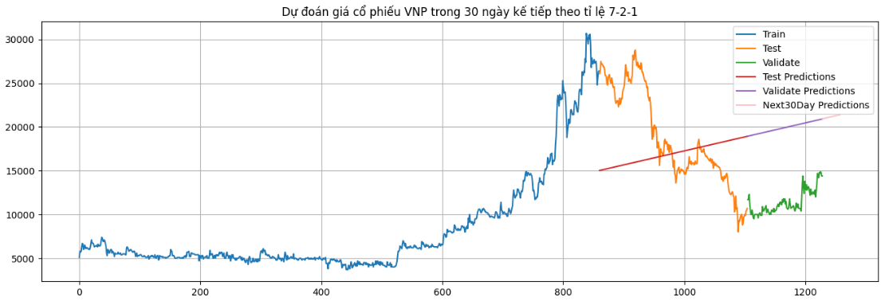

Predictive results of the Linear Regression model for VNP with the rate of 7-2-1 (%)

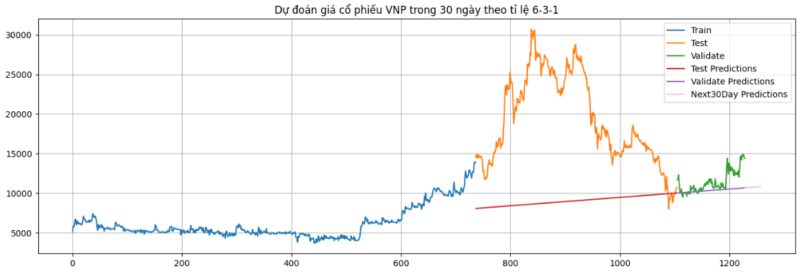

Predictive results of the Linear Regression model for VNP with the rate of 6-3-1 (%)

Predictive results of the Linear Regression model for VNP with the rate of 5-3-2 (%)

Predictive results of the BSTS model for VNP with the rate of 7-2-1 (%)

Predictive results of the BSTS model for VNP with the rate of 6-3-1 (%)

Predictive results of the BSTS model for VNP with the rate of 5-3-2 (%)

Predictive results of the ARIMA model for VNP with the rate of 7-2-1 (%)

Predictive results of the ARIMA model for VNP with the rate of 6-3-1 (%)

Predictive results of the ARIMA model for VNP with the rate of 5-3-2 (%)

Predictive results of the ARIMAX model for VNP with the rate of 7-2-1 (%)

Predictive results of the ARIMAX model for VNP with the rate of 6-3-1 (%)

Predictive results of the ARIMAX model for VNP with the rate of 5-3-2 (%)

Predictive results of the GRU model for VNP with the rate of 7-2-1 (%)

Predictive results of the GRU model for VNP with the rate of 6-3-1 (%)

Predictive results of the GRU model for VNP with the rate of 5-3-2 (%)

Predictive results of the KNN model for VNP with the rate of 7-2-1 (%)

Predictive results of the KNN model for VNP with the rate of 6-3-1 (%)

Predictive results of the KNN model for VNP with the rate of 5-3-2 (%)

# V. CONCLUSION

The results of this study demonstrate that out of the five models tested (Linear, ARIMA, ARIMAX, LSTM, KNN, CNN, BSTS, HMM, GRU), the most suitable for predicting the future price of VIC, VNP and CMG stocks in the resulting time series was LSTM, GRU, CNN model. The other models, including the Linear, ARIMA, ARIMAX, KNN, BSTS, HMM did not perform as well. This study highlights the importance of considering a variety of modeling approaches in financial analysis, and the potiential value of using LSTM, GRU, CNN model for predicting stock pirces in the future. Further research could be conducted to verify the results of this study and to investigate the performance of the other models on different types stock price prediction tasks.

**ACKNOWLEDGEMENT**

First and foremost, I would like to express my deepest gratitude to ***Assoc. Prof. Dr. Nguyễn Đình Thuân***, ***Mr. Nguyễn Minh Nhựt*** and ***Ms.Nguyễn Thị Viết Hương*** who always cared for our team during this course. I appreciate your assistance and the sharing of your valuable experience, which will help us accomplish our project. I would sincerely like to thank ***Mr. Nhựt*** and ***Ms. Nguyễn Thị Viết Hương***, who teaches and supports our team throughout our course.

# VI. GROUP ASSIGNMENT

|  |  |  |  |
| --- | --- | --- | --- |
| TASK | HUY | NGHIA | THANH |
| Introduction |  |  | x |
| Data collection |  | x |  |
| Data pre-processing | x |  |  |
| Linear Regression |  |  | x |
| ARIMA | x |  |  |
| LSTM |  | x |  |
| GRU |  |  | x |
| ARIMAX | x |  |  |
| KNN |  |  | x |
| HMM |  | x |  |
| BSTS | x |  |  |
| CNN |  | x |  |
| Writing paper | x | x | x |
| Writing report | x | x | x |

# VII. REFERENCES

[1] P.-F. Pai and C.-S. Lin, “A hybrid ARIMA and support vector machines model in stock price forecasting,” *Omega*, vol. 33, no. 6, pp. 497–505, Dec. 2005, doi: 10.1016/j.omega.2004.07.024.

[2] S. Hochreiter and J. Schmidhuber, “Long Short-Term Memory,” *Neural Computation*, vol. 9, no. 8, pp. 1735–1780, Nov. 1997, doi: 10.1162/neco.1997.9.8.1735.

[3] M. Rahman, Md. S. Hossain, T.-S. Junaid, M. Forhad, and M. Hossen, “Predicting Prices of Stock Market using Gated Recurrent Units (GRUs) Neural Networks,” vol. 19, pp. 213–222, Jan. 2019.

[4] “Vingroup JSC Stock Price Today | HM VIC Live Ticker,” *Investing.com*, Jun. 19, 2023. https://www.investing.com/equities/vingroup-jsc (accessed Jun. 19, 2023).

[5] “About Linear Regression | IBM.” https://www.ibm.com/topics/linear-regression (accessed Jun. 19, 2023).

[6] “Multiple Linear Regression,” *Corporate Finance Institute*. https://corporatefinanceinstitute.com/resources/data-science/multiple-linear-regression/ (accessed Jun. 19, 2023).

[7] A. Graves and J. Schmidhuber, “Framewise phoneme classification with bidirectional LSTM and other neural network architectures,” *Neural Networks*, vol. 18, no. 5, pp. 602–610, Jul. 2005, doi: 10.1016/j.neunet.2005.06.042.

[8] S. Varsamopoulos, K. Bertels, and C. Almudever, *Designing neural network based decoders for surface codes*. 2018.

[9] C. Cai, Y. Tao, T. Zhu, and Z. Deng, “Short-Term Load Forecasting Based on Deep Learning Bidirectional LSTM Neural Network,” *Applied Sciences*, vol. 11, no. 17, Art. no. 17, Jan. 2021, doi: 10.3390/app11178129.

[10] “Gated Recurrent Unit,” *DeepAI*, May 17, 2019. https://deepai.org/machine-learning-glossary-and-terms/gated-recurrent-unit (accessed Jun. 19, 2023).

[11] “Gated Recurrent Unit Networks,” *GeeksforGeeks*, Jul. 09, 2019. https://www.geeksforgeeks.org/gated-recurrent-unit-networks/ (accessed Jun. 19, 2023).

[12] A. dprogrammer, “RNN, LSTM & GRU,” *dProgrammer lopez*, Apr. 06, 2019. http://dprogrammer.org/rnn-lstm-gru (accessed Jun. 19, 2023).

[13] “Understanding Time Series Modelling with Auto ARIMAX.” https://www.analyticsvidhya.com/blog/2021/11/basic-understanding-of-time-series-modelling-with-auto-arimax/ (accessed Jun. 19, 2023).

[14] “What Is an ARIMAX Model?,” *365 Data Science*, Jun. 25, 2020. https://365datascience.com/tutorials/python-tutorials/arimax/?fbclid=IwAR2vLxhkK4dSXG3SafC71KF0VRDyuR7WQ31WDKjgG5OcaGr1zbRAS-romRY (accessed Jun. 19, 2023).

[15] “What is the k-nearest neighbors algorithm? | IBM.” https://www.ibm.com/topics/knn (accessed Jun. 19, 2023).

[16] “Hidden Markov Model in Machine learning,” *GeeksforGeeks*, Mar. 13, 2023. https://www.geeksforgeeks.org/hidden-markov-model-in-machine-learning/ (accessed Jun. 19, 2023).

[17] “Bayesian structural time series,” *Wikipedia*. Mar. 05, 2023. Accessed: Jun. 19, 2023. [Online]. Available: https://en.wikipedia.org/w/index.php?title=Bayesian\_structural\_time\_series&oldid=1143054281

[18] “Bayesian Structural Time Series | Bean Machine.” https://beanmachine.org/docs/overview/tutorials/Bayesian\_Structural\_Time\_Series/BayesianStructuralTimeSeries/?fbclid=IwAR3BK4WMptwoegf8xeuXzc-4MS-iuWLAFUbiX\_mUvwrta4WfkUfZK4BUxAI (accessed Jun. 19, 2023).

[19] “What are Convolutional Neural Networks? | Definition from TechTarget,” *Enterprise AI*. https://www.techtarget.com/searchenterpriseai/definition/convolutional-neural-network (accessed Jun. 19, 2023).